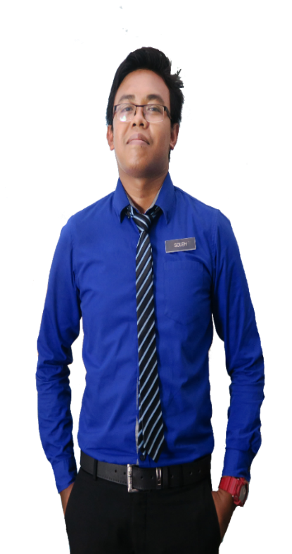

Prof. Dr. Mohamad Suffian Mohamad

Academic Advisor

Kolej Kediaman Tun Syed Zahiruddin

Universiti Teknologi Mara

[suffian_annuar@um.edu.my](mailto:suffian_annuar@um.edu.my)

+60160-2190 5697

Prof. Dr. Mohamad Suffian Mohamad

Academic Advisor

Kolej Kediaman Tun Syed Zahiruddin

Universiti Teknologi Mara

[suffian_annuar@um.edu.my](mailto:suffian_annuar@um.edu.my)

+60160-2190 5697

**//**

**REFERENCE**

**PER SKILLS**

**//**

**Analytical**

**Creative**

**Energy**

**Teamwork**

**Motivation**

**Positive**

**P:** 013-2805916

**E:** resumecreative@yahoo.com

**CONTACT**

MS Word

HTML/CSS

InDesign

Illustrator

Photoshop

Wordpress

**PROFESSIONAL SKILLS**

**//**

* Graphic Design Award 2015, Kuala Lumpur
* Anugerah Guru Cemerlang SMK Bandar Baru Sungai Buloh 2016
* Larian Hari Sukan Negara 2016, UiTM Kampus Puncak Alam
* Volunteer for SUKMA 18, Pahang Darul Makmur
* Creative and Innovation Awards 2017
* Anugerah Perkhidmatan Cemerlang Daerah Gombak
* Pengurusi Kelab Rakan Mude Daerah Gombak 2014
* Setiausaha Persatuan Perguruan Daerah Temerloh
* Exco Multimedia Majlis Perwakilan Pelajar UiTM 2015

**ACHIEVEMENT**

**//**

Implements curriculum objectives and goals using effective teaching techniques and materials. Develops, in a cooperative manner with the principal and curriculum facilitators, a plan for the improvement and enrichment of instruction.

*Teacher*

**SEKOLAH MEN KEB KUALA TEKAL**

**2013 – 2016**

**PAHANG**

Implements curriculum objectives and goals using effective teaching techniques and materials. Develops, in a cooperative manner with the principal and curriculum facilitators, a plan for the improvement and enrichment of instruction.

*Teacher*

**SEKOLAH MEN KEB BANDAR BARU SG BULOH**

**2013 – 2016**

**SELANGOR**

Teach at undergraduate and graduate level in areas allocated by the Head of Department and reviewed from time to time by the Head of Department. Carry out research and produce publications, or other research outputs, in line with personal objectives agreed in the Staff review process.

**2013 – 2016**

**SELANGOR**

**UNIVERSITI TEKNOLOGI MARA SHAH ALAM**

*Lecturer*

**//**

**EXPERIENCE**

**2013 – 2016**

**KEDAH**

*Sijil Pelajaran Malaysia*

**SEKOLAH MEN KEB JELAI (F), GEMAS**

**2013 – 2016**

**N. SEMBILAN**

CGPA: 3.93

*Science Stream (Module II)*

**KOLEJ MATRIKULASI KEDAH, CHANGLUN**

**MUHD SOLEH**

CGPA: 3.93

*Bachelor of Education In Science (Hons) Chemistry*

**UNIVERSITI TEKNOLOGI MARA KAMPUS PUNCAK ALAM**

**2013 – 2016**

**SELANGOR**

CGPA: 3.93

*Master of Education in Chemistry*

**2013 – 2016**

**SELANGOR**

**UNIVERSITI TEKNOLOGI MARA SHAH ALAM**

**EDUCATION**

**//**

Master’s degree in Science with four years’ experience teaching high school Science, Chemistry, and Additional mathematic. Certification in teaching Science and also professional in graphic design and video editor.

***LECTURER & GRAPHIC DESIGNER***

**//**

**Creative Resume, 74000 Bandar Puncak Alam, Selangor**

twitter.com/creativeresume

facebook.com/resumecreative